**HOW TO COOK BANGA SOUP**

Delta banga soup is best served with starch or eba.  
This is unlike the other banga stew that is native to the Igbos and popularly served with white boiled rice or yam.

This Banga soup is indigenous to the Deltans but also loved and enjoyed by both People from Edo state and all of the Niger Delta. If you are looking to make the Igbo version please click – [Igbo Banga Stew](https://allnigerianfoods.com/banga-stew).

This is not banga stew but they are both made with similar ingredients. Banga stew is native to the Igbos and usually served with boiled white rice. While banga soup (as in this case) goes with starch, eba or fufu.  
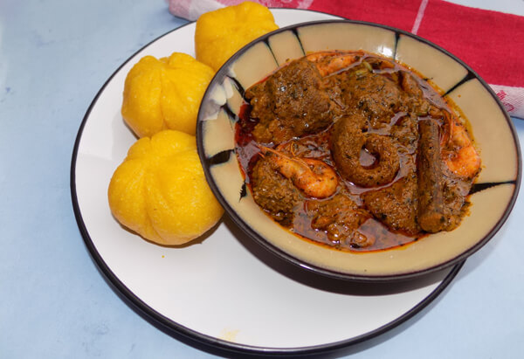

You can use any combination of meat for this soup or just use plain red meat; I used a combination of cow head, foot and red meat.

Ingredients | Serving: 12 Persons.

* Meat (1kg)
* Crayfish (half cup)
* Fresh prawn [oporo](one cup)
* Fresh Palm Fruits (Banga) (8 cups)
* Medium sized dry fish / smoked fish (1)
* Red scotch bonnet pepper “Ata rodo” (8)
* Ataiko (1 tbsp)
* Irugege (1 teaspoon)
* Oburunbebe Stick (Banga stick) (1)
* Dried Beletientien leaves (half cup) or
* Thinly sliced bitter leaves (half cup)
* 3 cubes of knorr
* Periwinkles (1)
* Salt to taste.

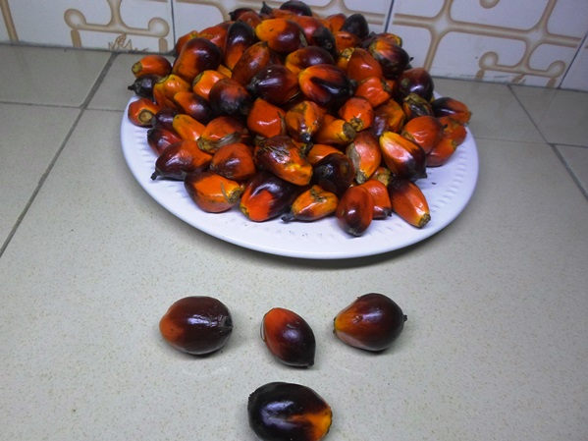  
These are banga seeds (Mpuru akwu) they are the major ingredients for making this soup. Akwu is very abundant in Nigerian.

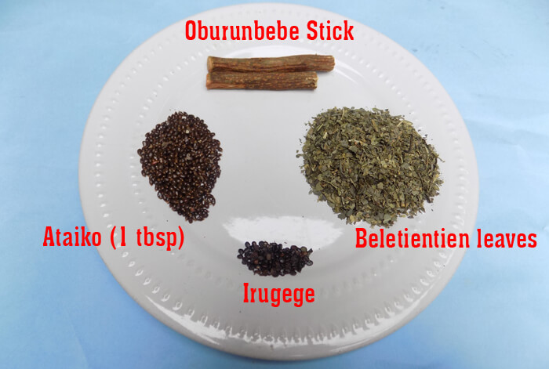  
These are pictures of some of the ingredients for this Itsekiri soup. All of these spices and ingredients can be purchased from any Nigerian local market. For the spices and banga stick, ask those women that sell traditional roots and herbs like zobo leaves and dogoyaro.

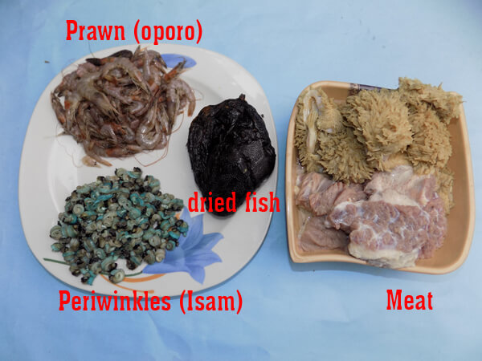

You should use crushed dried beletientien leaves, also called atama leaf in Efik or thinly sliced bitter leaves.

Start by grinding the spices. Add them all together (ataiko, Irugege and a cup of crayfish), blend to powder. Blend the pepper also. Wash the dried or smoked fish and remove center bones.

wsh and precook the prawn, use half cup of water, a cube of maggi and a pinch of salt.

I used already precooked meats. If your meat is not precooked yet, do that now. Wash properly and use two cubes of knorr and a pinch of salt. Cook the meat until it becomes soft, easy to chew and the water is almost dried. Add salt to taste and allow another three minutes. Set aside.

Boil the palm fruit for 20 minutes, pound with a mortar and pestle, transfer into a bowl, add water and extract the juice. You will need about 7-10 cups of that palm fruit juice for this cooking. It should be thick.  
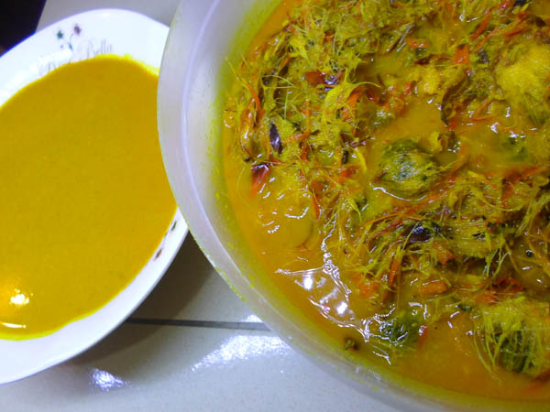

Use a sieve to strain the extract into your cooking pot, allow to boil for 15 minutes with the pot half-covered. It should be a lot thicker now.

Add the cleaned dried fish, ground (crayfish, ataiko plus irugege), oburunbebe stick, precooked meat, ground pepper and salt to taste. Cover and allow another 10 minutes.  
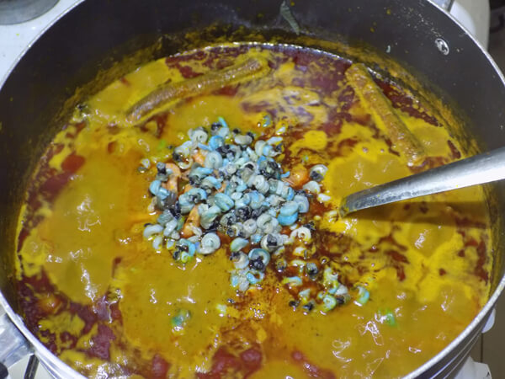

Add the crushed dried beletientien leaves or thinly sliced bitter leaves, precooked prawn, periwinkles and one cube of knorr. Stir, cover and allow to simmer for 3 minutes. This is how to make the popular banga soup that is loved and made by the Deltans.  
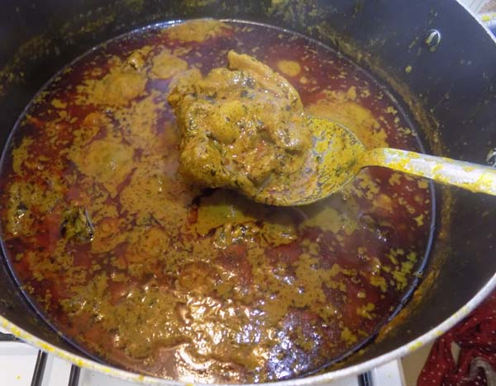

Serve with starch, eba or fufu.